Hilton Hotels Six Sigma Implementation

Name
Institution

Table of Contents
Abstract 3
Six Sigma Implementation Guide 4
Phase 1: Envisioning 5
Phase 2: Strategizing 6
Phase 3: Developing 7
Phase 4: Implementing 8
Phase 5: Improving 8
Phase 6: Sustaining 9
Phase 7: Abandonment 9
Conclusion 10

Abstract
With just a few Hotels already implementing Six Sigma and Lean Management, the report explains DMAIC’s role in redesigning and improving operations across Hilton Hotels. Six Sigma is a tedious and costly process that needs extensive funding and commitment among the staff. Successful delivery depends on the synergy achieved across all the affected departments, and of course, Six Sigma is likely to affect nearly all the departments in the organization. Presently the customers use manual methods to book and confirm their stay at the hotel, however, the Six Sigma methodology proposed a Check-in and Check-out system that would automate and synchronize the booking. The employees would prepare to serve their customers and the customers would know which empty rooms exist so that they could book according to their budget and length of stay.

Six Sigma Implementation Guide
The report already started working with Hilton Hotel, and the specific branch identified had 100 employees. Six Sigma needs to know the details about the hotel number of employees as it directly affects the amount needed to fund the project. The 100 staff might need a relatively short amount of time. The size of the facility and services offered determines the resources and time needed to implement and operationalize the Six Sigma across an institution not only in the hospitality sector but also across all sectors. Not all departments become affected, but the changes would surely affect the efficiency in operations. Human beings are tough to oblige to change requests by nature, thus, the report suggests rolling out the Six Sigma across departments at a slow pace, before going full blast. The report also focuses on training requirements that employees require if they must get used to and take advantage of all the features associated with the Six Sigma Check-in and check-out system.
Before proposing solutions, there must have been challenges experienced at one or all of Hilton Hotels’ branches. Six Sigma has always become fruitful in the manufacturing sector, and it is anticipated that it would yield success in Hilton, which operates in the hospitality service sector. According to Tetteh and Chapman, (2018), Hilton takes immense reports about the supplies, housekeeping, food, beverages, customer details, and bookings. The hospitality sector is a bit dynamic and sensitive, which means Six Sigma must become very specific about the changes it needs to perform. Hilton chain of hotels got departments that run in different silos, for instance, Hilton’s marketing department could generate and publicize a marketing technique without the housekeeping department’s awareness. The proposed Six Sigma would require synergy across most if not all departments, from accounts, sales, housekeeping, kitchen, and stores.
Six Sigma Check-in and Check-out would bring forth several benefits, however, obstacles lie forth the process. Some people might lose positions and Hilton must recruit new staff, especially those who are tech-savvy and all-around. Six Sigma needs commitment from all the involved parties. The process needs huge funding depending on the facility’s size because of additional procedures that accompany the check-in and check-out system implementation, Tetteh and Chapman, (2018). Several stakeholders get involved in the investment such as customers, employees, managers, and even lending institutions who interact in an uncertain economy.

Phase 1: Envisioning
The corporate level envisions the Hilton’s check-in and check-out system. The management identified the need and importance of letting Six Sigma turn around the fundamental processes at the facility particularly, the check-in and check-out processes. Salah and Rahim, (2018) explained that the management agrees on the core implementation methodology before drumming support for its implementation across the organization. Hilton’s corporate set aside resources for installation, training, and maintenance. Apart from the sensitization process, Hilton’s corporate must align the Six Sigma to its organizational culture.
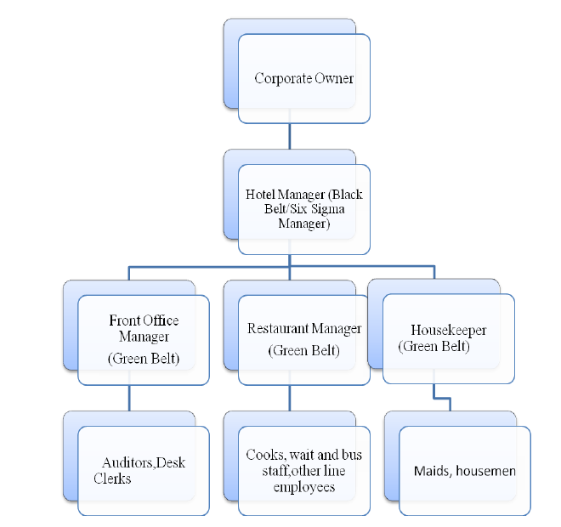

Phase 2: Strategizing
Training and development programs are necessary to equip the staff with the relevant skills needed to operate the new check-in and check-out system. According to Taylor, (2019), the management takes keen consideration of the overlapping roles at Hilton Hotels. The report suggested that Hilton’s management could outsource organizations that specialize in Six Sigma implementation alongside Lean Principles. A manager at Hilton appointed would help the outsourced team implement the Six Sigma without interfering with the normal operations at the hotel.
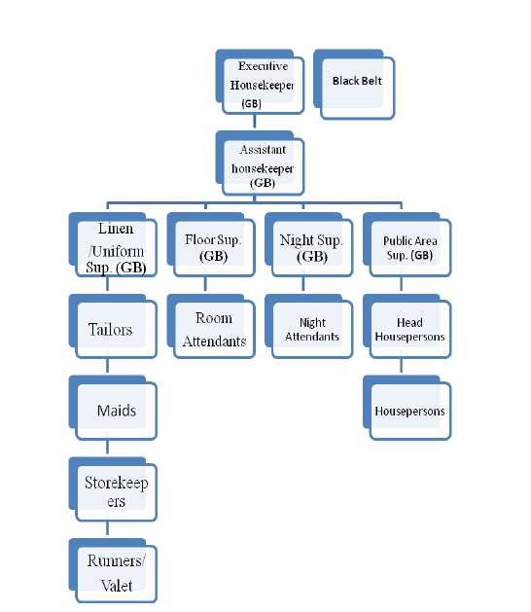

Phase 3: Developing
The Six Sigma identifies the areas that require new skills and change of operations from manual to electronic. The Six Sigma changes take place organization-wide affecting areas such as Hilton’s website, hotel reception, housekeeping, and laundry and kitchen departments. Chatterjee, (2016) explained that with the manual system, the customers never know the rooms available, neither do the hotel know if they expect guests who might overwhelm their limited rooms. The Six Sigma’s check-in and check-out system would transform the operations and improve vita operations such as room reservation and booking, depending on the availability

Phase 4: Implementing
All staff at Hilton must take part in the Six Sigma implementation. The outsourced team spearheads the process together with the management. The employees' issue feedback on areas they feel is not well emphasized. Taylor, (2019) explained that the project gets implemented in portions so as not to overwhelm the Hilton’s staff. Some staff has never worked in a digital environment, thus rolling out such a plan across the organization at once might interfere with their mode of work. The phase probably becomes the most tedious because it involves the installation and commissioning of the online check-in and check-out system and staff training. The company also performs sensitization and marketing programs that inform existing and potential customers about the sudden change in operations.

Phase 5: Improving
After the implementation phase, Hilton Hotel’s management together with the outsourced teamwork to ensure that the check-in and check-out system not only does what was designed of it, but also that it properly meets the objectives. According to Taghizadegan, (2019), the stage acts as the evaluation phase of the system. The hyped new system must have rendered certain benefits to Hilton Hotel, otherwise, there would have not been any reason to implement it at all. Hilton Hotel operates in the hospitality sector and any glitch in the system or change of operations might cause them a big loss in customers. The company must evaluate the system for any challenges experienced, not within the system, but also among customers and employees when dealing with the system.
Any challenges identified in the previous stages can get addressed at the stage. Notable challenges might force the Six Sigma team to put off the plan. More so if the company faces a challenge that costs a lot more to rectify then they could consider reverting to the old manual system. Project failures are easy to spot at an early stage, for instance, poor staff buyout of the system could force the entire system to be put on hold. Minor failures do not require the system implementation to get to a halt, instead, it just gets revised and improved to meet Hilton Hotel.

Phase 6: Sustaining
If properly implemented, the Six Sigma’s check-in and check-out system would become successful. However, Hilton Hotel got the workload to make sure that everything goes on as planned. The benefits of Six Sigma if noted within the company, the staff would embrace it and support its functionalities. The Six Sigma implementation comes along with changes that usually interrupts the normal operational culture. The management got a big task making sure that the staff follows the new rules and requirements within the check-in and check-out system. The management must keep all staff accountable from their respective departments concerning the system. Each person must perform their respective tasks if the check-in and check-out system become a success.

Phase 7: Abandonment
System abandonment can happen at any stage of the Six Sigma implementation. Hilton Hotel needs a team of internal staff to work alongside the contractual team if the Six Sigma implementation is to succeed. The process is not only tedious but also demands intense changes that some employees might not withstand such demands. Keeping employees prepared and in check throughout the Six Sigma implementation procedure makes them kept in check. Hilton Hotel also could collect feedback from customers and employees during the Six Sigma implementation so that if any problem occurs, it is easily spotted and rectified at an early stage.

Conclusion
In sum, the report acted as a tool to help Hilton Hotel and other facilities within the hospitality sector to implement Six Sigma in a controlled environment. Six Sigma is a relatively large organization needed to tweak a few parts of the Six Sigma for the implementation to occur smoothly across all its departments. Hilton Hotel got the opportunity to monitor and control the amount used in implementing the Six Sigma across its hotels. Hilton Hotel could even implement the Six Sigma on a tight budget.
References
Chatterjee, B. (2016). Applying Lean Six Sigma in the Pharmaceutical Industry.
Salah, S., & Rahim, A. (2018). An Integrated Company-Wide Management System: Combining Lean Six Sigma with Process Improvement.
Taylor, G. M. (2019). Lean six sigma service: A guide to green belt certification and bottom line improvement. Boca Raton, Fla: Ross Publ.
Taghizadegan, S. (2019). Essentials of Lean Six Sigma.
Tetteh, E. G., & Chapman, H. (2018). Lean six sigma for optimal system performance in manufacturing and service organizations: Emerging research and opportunities.

